NAME: __________________________ DATE DUE: ____________
TEACHER: ________________________
/31
Year 9 Term 4 – Body Systems
HOMEWORK SHEET No. 2 – Learning Goal 2

 | - Write a definition and give an example of each of the following terms:
/1 | (a) Digestion –
/1 | (b) Nutrient –
/1 | (c) Saliva -
/1 | (d) Enzyme -
/1 | (e) Gastric Juice -
/1 | (f) Absorption -
/1 | (g) indigestion -
/2 | - (a) List, in the correct order, the five organs which food passes through in your body
/2 | (b) List the two “accessory organs” (organs of the digestive system which help digestion but which food does not pass through)
 | - In a single sentence describe the role of each of the following organs of the digestive system.
/1 | (a) Stomach -
/1 | (b) Large Intestine -
/1 | (c) Mouth -
/1 | (d) Liver -
/1 | (e) Oesophagus -
/1 | (f) Small Intestine -
/1 | (g) Pancreas -
/3 | - Complete this simple venn diagram:  Mechanical digestion  Chemical digestion
 | - Correctly label the diagram of the human digestive system
/6 | 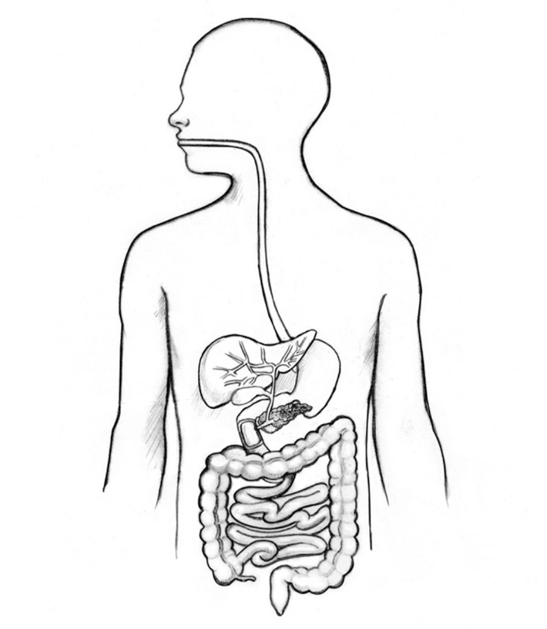
- Antacid medication is used in the treatment of indigestion, caused by excess (too much) stomach acid. Antacid medication usually claim to do one or more of the following
    - Neutralise some of the acid, that is, increase the pH of the stomach acid
    - Act in a reasonably short period of time
    - Do no short term harm to the stomach by not neutralising “too much” stomach acid.
In a brief paragraph (less than 100 words) outline a experimental process you could go through to test one of these three claims
/4
 | Directive verbs | Meaning
 | Define | Gives the meaning of the word, phrase, or concept.  Typically begins with: A “____________“ is...
 | Describe | Give an account of a situation, event, pattern, or process or give an account of the characteristics or features of something.  Describing is the “what, not the “why”. This means that describing should only tell you what something is, what it looks like, or what it does. Describing does not explain or justify - these two words are the “why” descriptive verbs

